PROFILE

OUR TEAM

- Mohammad Younus
Senior Fire & Life Safety Engineer
Fire & Life Safety NFPA Approved Instructor/ Trainer with 13+ years experience in NFPA, IFE, and safety training across India & the Gulf.


- Rabbe Alam
Senior Fire Protection Engineer
Licensed Fire Protection P.E (USA)
Dedicated Fire Safety Trainer with 15 years of experience delivering NFPA, IFE, and occupational safety training to students and professionals across India and the Gulf.


- Ahmed Anwar Albarak
Fire Prevention Engineer
Saudi Energy

- Javed Alam Khan
Fire & Life Safety Consultant
NEOM

5. Asif Alam Khan
Senior Fire Inspector
Saudi Energy
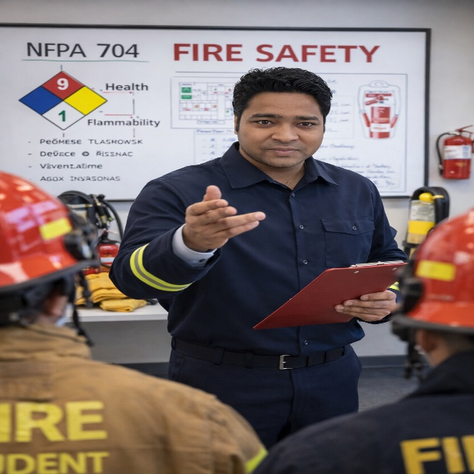
- Faisal Iqbal
Project Director – Fire Section

- Salim Ansari
Engineering Manager – Fire Division
REDA Hazard Control


8. Zafar Imam Kaifi
Fire Prevention Specialist
More than 13 years of experience in the fire protection field.

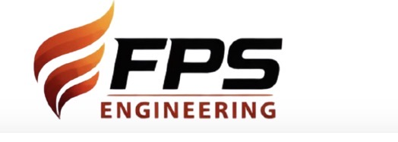
Fire Protection Solutions & Engineering

Your Trusted Partner in Fire Protection, Life Safety & Technical Training

⭐ About Us (What we are)
Fire Protection Solutions & Engineering is a specialized training and consultancy institute dedicated to elevating fire safety, security, computer courses and risk management standards across industries.
We deliver globally recognized technical training, Preparation courses, skill development programs and professional fire system inspection services based on NFPA Codes, Indian Building Codes, and international best practices.
With expert trainers and real-world field experience, we help professionals, organizations, and students build strong competencies in fire protection engineering, safety management, and security system technologies and computer class training.

🚀 Our Mission
To advance fire and life safety by empowering professionals and industries through high-quality fire protection education, internationally recognized certification training, code-compliant inspections and engineering consultancy, delivering practical, standards-driven solutions aligned with global safety regulations and best engineering practices.

🌟 Our Vision
To become a leader in fire and life safety education, inspection and engineering consultancy by setting excellence benchmarks in professional training, technical competency and code-compliant safety solutions, contributing to a safer and more resilient global built environment.

💡 Our Core Values

Safety First
Safety is our highest priority and the foundation of all our activities. We are committed to fostering a strong safety culture through risk-based thinking, hazard identification, preventive controls, and compliance with recognized fire, life safety, and occupational health standards. Our objective is to protect people, assets, and the environment at all times.

Technical Excellence
We uphold the highest standards of technical competence and engineering accuracy in training, inspection, and consultancy services. Our programs are developed and delivered in alignment with NFPA, ICC, NEBOSH, OSHA, and other international codes and standards, ensuring industry-relevant, practical, and reliable outcomes.

Integrity & Compliance
We conduct all operations with professional integrity, transparency, and ethical responsibility. Compliance with applicable codes, regulations, and certification body requirements is non-negotiable. We maintain objectivity, independence, and accountability in all training, assessment, and advisory engagements.

Regulatory Alignment
We emphasize strict alignment with local authority requirements and international regulatory frameworks, ensuring that our training and consultancy solutions support audit readiness, inspection compliance, and regulatory approvals across different jurisdictions.

Innovation & Adaptability
We continuously adopt modern training methodologies, updated codes, and emerging technologies to enhance learning effectiveness and system understanding. Our approach integrates innovation with proven engineering principles to address evolving fire, safety, and security risks.

Continuous Professional Development
We believe that professional competence requires lifelong learning. Our institute promotes continuous development through updated curricula, code revisions, practical case studies, and competency-based training, enabling professionals to remain current in a rapidly advancing safety environment.

Practical & Application-Based Learning
We focus on real-world applicability, bridging the gap between theory and practice. Our training emphasizes practical understanding, system behavior, and field-relevant scenarios, preparing participants for actual site conditions, inspections, and operational challenges.

CLIENT & STAKEHOLDER PARTNERSHIP
We work as a long-term technical partner with clients, utilities, EPC contractors, and authorities, delivering customized, project-specific solutions that support operational continuity and compliance.

Professional Responsibility
We recognize our responsibility in shaping competent safety professionals. Our training and guidance are delivered with a commitment to public safety, engineering ethics, and professional accountability, ensuring responsible decision-making in safety-critical environments.

🌍 Why Choose Us
- Industry-certified global instructors
- Real incident-based practical teaching
- Code-accurate, standard-driven technical content
- Hands-on training with actual systems
- Support for exam preparation, career guidance & job readiness

💼 Who We Train
We support a diverse range of professionals, organizations and industries that rely on robust fire protection systems, safety excellence and technical competency. Our training programs are designed to address both individual professional development and organizational compliance requirements across multiple sectors.

👤 Professionals & Individuals
- Students and Engineering Students
- Safety Officers and Safety Professionals
- Emergency Responders
- Facility and Operations Managers
- Industrial and Non-Industrial Workers
- Professionals seeking specialization in fire, safety, and security systems

🏭 Industries & Organizations We Serve
- Power Generation and Utility Facilities
- Commercial Buildings and High-Rise Structures
- Manufacturing and Industrial Plants
- Oil & Gas and Petrochemical Facilities
- Data Centers and IT Infrastructure
- Healthcare and Educational Institutions
- Government and Public Safety Organizations
- Construction Companies and EPC Contractors
- Warehouses, Logistics, and Distribution Centers

🤝 Our Commitment
We collaborate closely with each individual to deliver tailored, technically accurate and code-compliant training and solutions that enhance operational safety, workforce competency and regulatory readiness, aligned with applicable international and local standards.

🎓 Our Training Programs

Fire Systems Certification & Training Courses
Professional exam coaching by certified instructors covering and Hands-on and theory-driven programs covering:
Fire Protection Solutions & Engineering which provides comprehensive education and training based on the standards set by the National Fire Protection Association (NFPA), The Institute of Fire Engineers (IFE-UK), National Institute for Certification in Engineering Technologies (NICET-USA) & National Building codes (India). Our program is designed to equip individuals and organizations with the knowledge and skills necessary to ensure fire safety and compliance with NFPA guidelines.
Fire Protection Solutions & Engineering Training program covers a broad spectrum of fire safety topics, including:
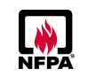
NFPA CERTIFICATION COURSES
- Certified Fire Protection Specialist (CFPS).
- Certified Fire Inspector (CFI)
- Certified Fire Inspector I (CFI-I)
- Certified Fire Inspector II (CFI-II)
- Certified Fire Plane Examiner (CFPE).
- Certified Fire Alarm ITM Specialist (CFAITMS) for Facility Managers
- Certified Hazard Recognition Specialist (CHRS)
- Certified Water-Based Fire Protection System Inspection, Testing, and Maintenance (WBITM)
FIRE PROTECTION & LIFE SAFETY SYSTEMS TRAINING COURSES
- NFPA 1 – Fire codes.
- NFPA 3 - Standard for Commissioning of Fire Protection and Life Safety Systems
- NFPA 10 – Standard for Portable Fire Extinguishers
- NFPA 11 - Standard for Low-, Medium, and High-Expansion Foam
- NFPA 13 - Standard for the Installation of Sprinkler Systems
- NFPA 14 - Standard for the Installation of Standpipe and Hose Systems
- NFPA 17 - Standard for Dry & Wet Chemical Extinguishing Systems
- NFPA 20 - Standard for the Installation of Stationary Pumps for Fire Protection
- NFPA 22 - Standard for Water Tanks for Private Fire Protection
- NFPA 25 – Inspection, Testing & Maintenance of Water-Based Systems.
- NFPA 70 - National Electrical Code®
- NFPA 72 - National Fire Alarm and Signaling Code®
- NFPA 80 - Standard for Fire Doors and Other Opening Protectives
- NFPA 101 - Life Safety Code®
- NFPA 2001 – Clean Agent Fire Suppression Systems
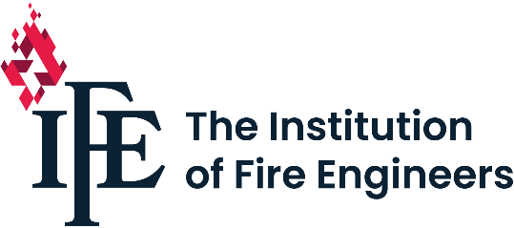
IFE PREPRATION COURSES: -
- Level 2 Certificate in Fire Science, Operations and Safety L2C
- Level 2 Award in Passive Fire Protection: Walls, floors, ceilings and glazing L2CP2.
- Level 2 Award in Passive Fire Protection: Fire stopping, barriers, ductwork and dampers L2CP3.
- Level 2 Award in Passive Fire Protection: Doors and shutters L2CP4.
- Level 3 Certificate in Passive Fire Protection L3CP.
- Level 3 Award in Fire Engineering Science L3C1.
- Level 3 Award in Fire Operations L3C2.
- Level 3 Certificate in Fire Safety L3D2.
- Level 4 Certificate in Fire Engineering Science L4C1.
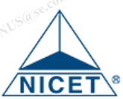
NICET PREPRATION COURSES: -
- Fire Alarm Systems certification Levels I – IV
- Inspection and Testing of Fire Alarm Systems, ITFAS exams.
- Inspection and Testing of Water-Based Systems Levels I – III.
- Special Hazards Systems Levels I – IV.

ICC INTERNATIONAL CODE COUNSIL PREPRATION COURSES: -
- ICC Fire Inspector I
- ICC Fire Inspector II
- ICC Fire Plans Examiner (F3)

🛡 International Safety Certifications Preparation

🎓 Professional Safety Certification Programs
- ASP® – Associate Safety Professional
(Board of Certified Safety Professionals – BCSP)
Preparatory training covering fundamental safety principles, hazard identification, risk control, and occupational safety management.
- CSP® – Certified Safety Professional
(Board of Certified Safety Professionals – BCSP)
Advanced certification preparation focusing on safety leadership, risk analysis, occupational health, and environmental safety management.
- NEBOSH International General Certificate (IGC)
Comprehensive preparation for managing international occupational health and safety risks, aligned with global industry practices.
- NEBOSH Safety Certificate Programs
Training support for various NEBOSH qualifications, focused on workplace hazard control, safety management systems, and regulatory compliance.
- OSHA – Occupational Safety and Health Administration
Training programs covering OSHA standards, workplace safety compliance, hazard prevention, and emergency preparedness.
- IOSH – Institution of Occupational Safety and Health
Preparatory training for IOSH-aligned programs, supporting safety professionals in developing competence in occupational health and safety management.

🔥 Security & Safety Systems-Based courses

🛠️ Technical Systems Training Programs
- CCTV Surveillance Systems
Training covering system design, installation, commissioning, operation, and maintenance, including camera selection, storage planning, and regulatory considerations.
- Access Control Systems
Comprehensive training on access control design, installation, configuration, testing, and maintenance, including integration with fire alarm and security systems.
- Building Management System (BMS)
Training on design principles, installation, operation, and maintenance of BMS, including integration of fire safety, HVAC, electrical, and security systems.

💻 Computer-Based Courses & Digital Skills Training
- Microsoft Office (MS Word, MS Excel, MS PowerPoint, MS Outlook, Data Analysis using).
- Data Entry Operator Training
- Computer-Based Soft Skills & Professional Development
- Data Science & Analytics Training

OUR CAPABILITIES & FACILITIES
Our institute is built on a strong foundation of technical infrastructure, experienced professionals, and specialized training teams, enabling us to deliver high-quality, standards-driven fire, safety, security, and engineering training programs globally.
3 Offices
(1. Surajpur, Greater Noida, Uttar Pradesh
2. Wazirabad, Delhi
3. Bareilly, Uttar Pradesh, India
| Globally Virtual Training |
300+ Professionals Trained (46 Engineer, 28 Fire Inspector, 176 Safety Professionals etc.)
NFPA Approved Trainers | Industrial Experts | 10+ Years Average Instructor Experience

📩 Get in Touch
Connect with Our Experts
For professional training, engineering consultancy, inspections and compliance verification related to fire, life safety, security and industrial systems, please contact our team.
We deliver reliable, standards-based solutions aligned with industry best practices.
📧 Email: firealarmsolutionengineering@gmail.com
📞 Contact: +91 7906715056 and +91-9667898493, +966-568382634
📍 Location:
Surajpur, Greater Noida, Uttar Pradesh
Wazirabad, Delhi
Bareilly, Uttar Pradesh, India
LINKEDIN
https://www.linkedin.com/company/112801333/admin/dashboard/
YOUTUBE

Frequently Asked Questions (FAQs)

1. What services do you provide?
We provide comprehensive services for commercial, industrial and infrastructure projects in below Areas.
Fire, Safety, Security training based on NFPA, IFE, ICC, NICET & Indian building codes.,
Inspections, testing of fire detection & protection Systems.
Engineering certification support like CFPS, CFI, CFPE, LC, etc
Building Inspection, Verification based on Code-Compliance.
Engineering consultancy like Design review, Technical report preparing etc…

2. Do you offer fire safety and technical training programs?
Yes, we offer professional fire safety, life safety, security and technical training programs tailored to industry requirements and organizational needs and individuals.

3. Are your training programs conducted onsite or at your facility?
Yes, our training programs are delivered via classroom-based sessions, accredited training centers and online/virtual platforms, ensuring flexible and global accessibility to meet client and project-specific requirements.

4. Do your courses comply with international standards?
Yes, our training and engineering practices are aligned with international standards and guidelines, including NFPA, IFE, NICET, SFPE, OSHA, and other applicable regulatory requirements.

5. Do you provide inspection and compliance verification services?
Yes, we provide inspection, testing, and compliance verification services for fire detection and protection systems, safety installations, and life safety systems in accordance with applicable codes and standards.

6. Can you support fire protection system design and consultancy?
Yes, we offer design review, engineering consultancy, technical support, and compliance assessment for fire alarm, firefighting, life safety, and integrated safety systems.

7. Do you assist with risk assessments and HSSE documentation?
Yes, we support HSSE risk assessments, risk registers, ALARP/RTAD documentation, method statements, and safety compliance reviews as part of our consultancy services.

8. Who are your typical clients?
We work with industrial facilities, commercial buildings, infrastructure projects, contractors, consultants, and facility management teams across various sectors.

9. Do you customize training and consultancy services?
Absolutely. Our services are fully customized to meet site-specific risks, regulatory requirements, project scope, and client objectives.

10. How can we request a quotation or consultation?
You may contact us via email, phone, or the contact form on our website. Our team will review your requirements and respond promptly with the appropriate support.

11. Do you provide post-training or post-inspection technical support?
Yes, we provide ongoing technical guidance and support following training programs, inspections, and consultancy engagements.

12. What makes your company different from others?
Our strength lies in practical industry experience, standards-based approach, professional delivery, and commitment to quality, safety, and compliance.

13. Do you arrange original reference books for examinations on a short-term basis?
Yes, we arrange original reference books to our joiner from for a short duration to support examination preparation for certifications such as CFPS, CFPE, and CFI, including official publications NFPA and other recognized bodies, subject to availability..s

14. Do you support practicum preparation after passing certification exams (e.g., Certified Fire Inspector)?
Yes, we assist candidates with practicum preparation after passing certification exams such as Certified Fire Inspector (CFI).
15. How can I contact you?
You can reach us via telephone, email, or WhatsApp for enquiries related to training programs, consultancy services, or general support.

🌐 WHERE WE SERVE
We offer our services across multiple regions, ensuring high-quality training and technical support wherever required:
- Across India
- Online & Virtual training available globally
Our scalable training model, remote consulting capability, and on-site inspection services allow us to support clients in multiple geographies with consistent quality and code compliance.

🔥 GALLERY
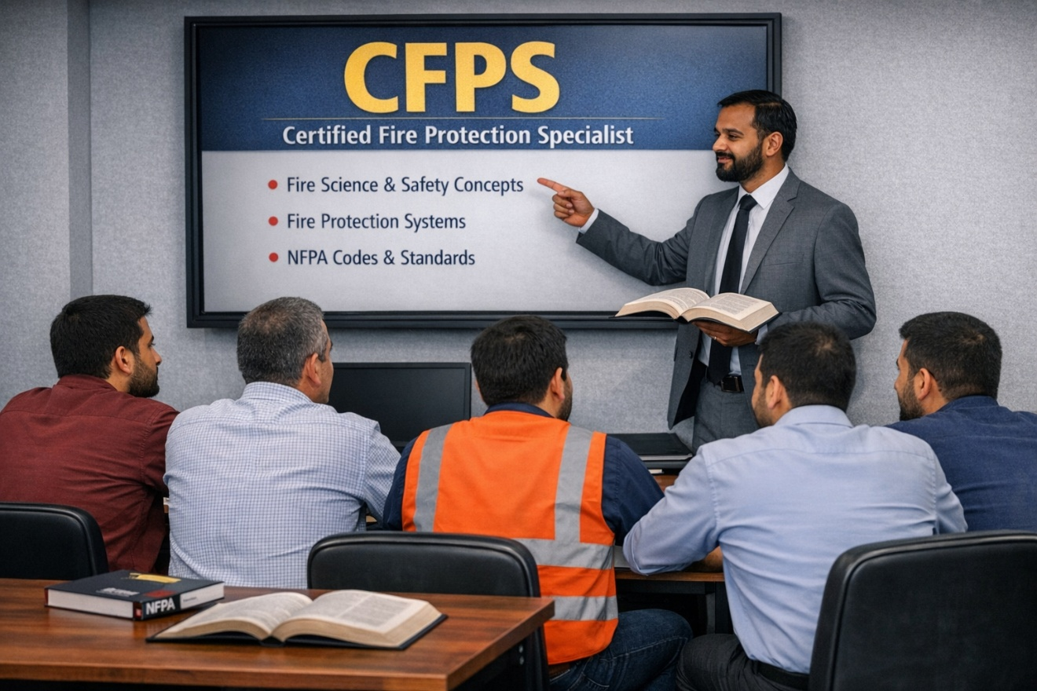

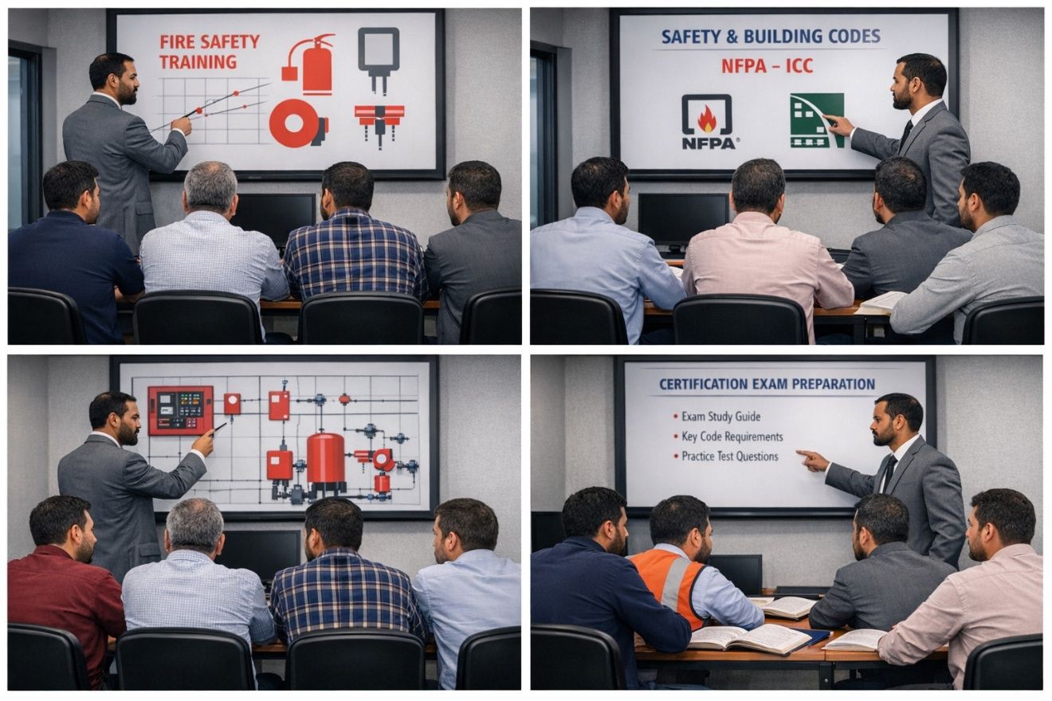

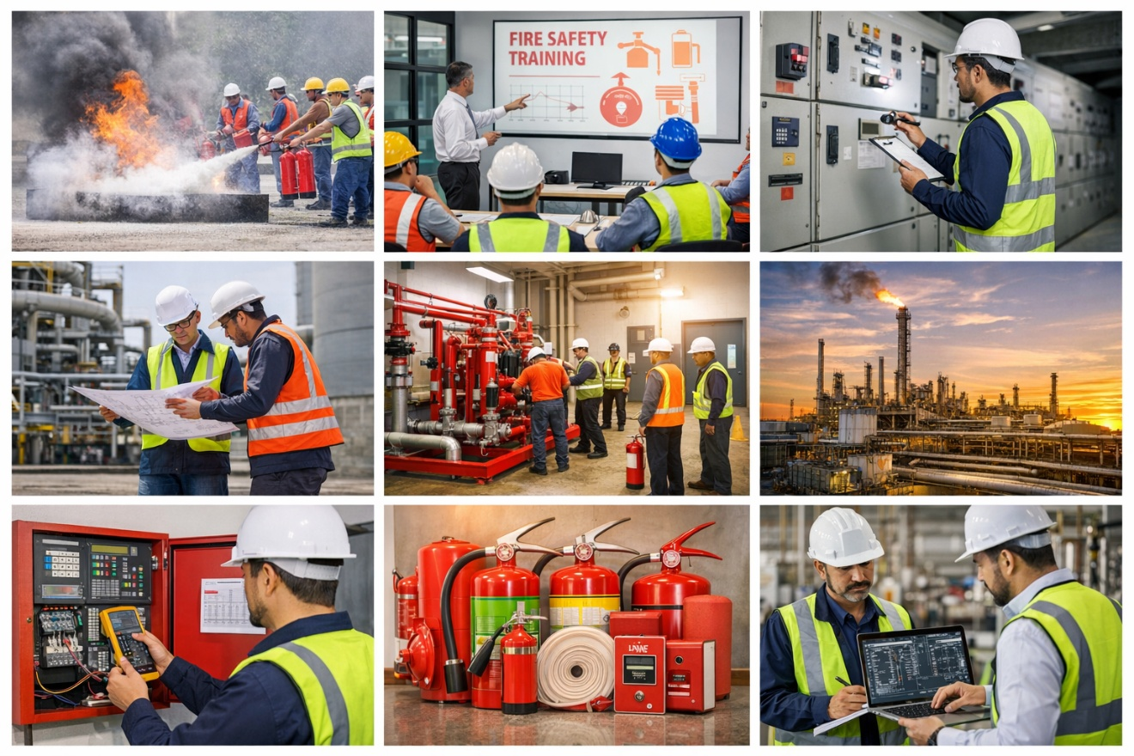

🔥 Fire & Life Safety Consulting Services
We provide a full spectrum of end-to-end fire & life safety Inspection, Assessment, Audit, system performance evaluation, technical report, fire investigation report, documentation covering:

🔥 Fire & Life Safety Consulting
- Fire systems inspection report
- NFPA & Indian Building Code compliance audits report
- System performance evaluation & technical reporting
- Fire investigation support & root-cause analysis
- Fire safety documentation and AHJ-required compliance reports

🔥 Fire Protection Systems Expertise
- Fire Alarm & Detection Systems
- Gas Detection Systems
- Clean Agent Systems: NOVEC 1230, FM-200
- CO₂ Systems: High & Low Pressure
- Wet Chemical Kitchen Hood Systems
- Water-Based Systems: Sprinkler (Wet, Dry, Pre-action, Deluge), Hydrant, Standpipe, Fire Hose Reel
- Fire Pumps Testing (Diesel/Electric/Jockey)
- Portable Fire Extinguishing Systems

🧱 Passive & Active Safety Systems
- Compartmentation assessment
- Fire doors, egress components, ramps & stair compliance
- Fire stopping & structural fire protection
- Life safety system evaluation (NFPA 101)

📋 Risk Assessment & Compliance
- Fire hazard identification & risk ranking
- Building occupancy & occupant load study
- Emergency evacuation & response planning
- Safety documentation & regulatory compliance verification

